5.1 Agents

The real-world GIS model including one distribution center, 50 customers spread across Beijing, and a fleet of 7 trucks that deliver the packages from the distribution center to customers. We import the latitude and longitude from the database of the distribution center and customers into the GIS map.



Figure 1. Agents

5.2 Trucks’ action

Building a state chart to define the trucks’ movement. Firstly, all the trucks’ initial locations are in the same GIS point as the distribution center. The 7 trucks need deliver packages like the following route in Figure 2. Therefore, the trucks select customers’ ID from the “route” database. Then the trucks upload packages in the distribution center. Loading takes time and the travel time is in the “dist_time_sample” database. The trucks deliver packages from one customer to another customer. After delivering all the packages the trucks will come back to the distribution center.



Figure 2. The route of trucks

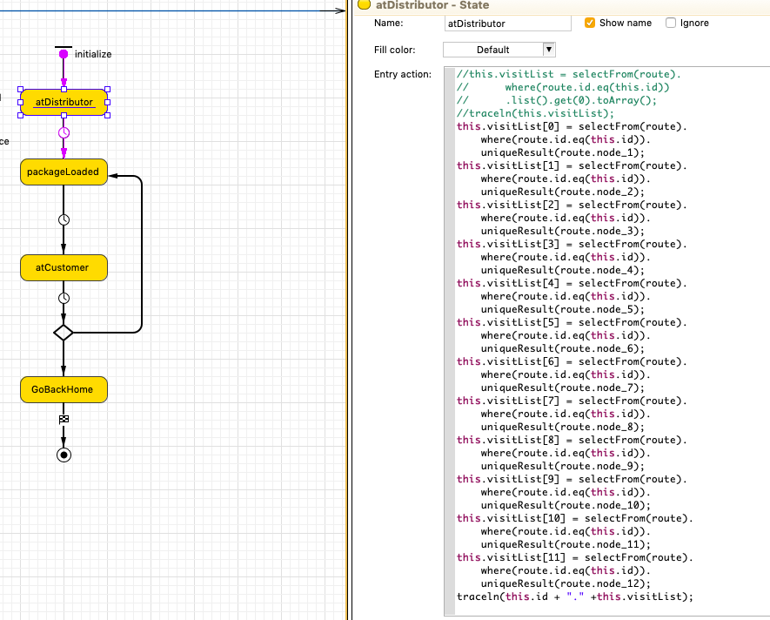

Figure 3. Action of distributor

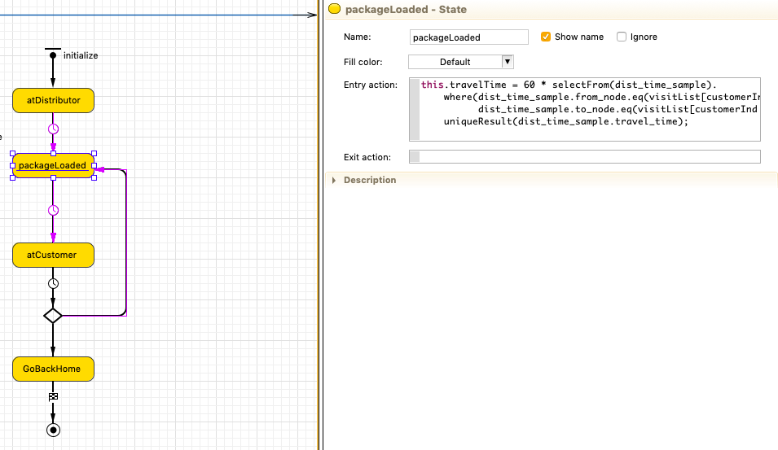

Figure 4. Action of loading package

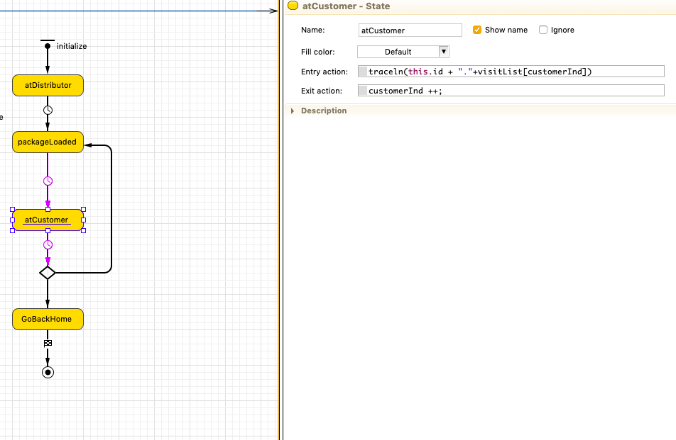

Figure 5. Action of customer

5.3 Running Model

This is the final stage, and we can run the model and observe the trucks going through the route and deliver packages according to the requests.

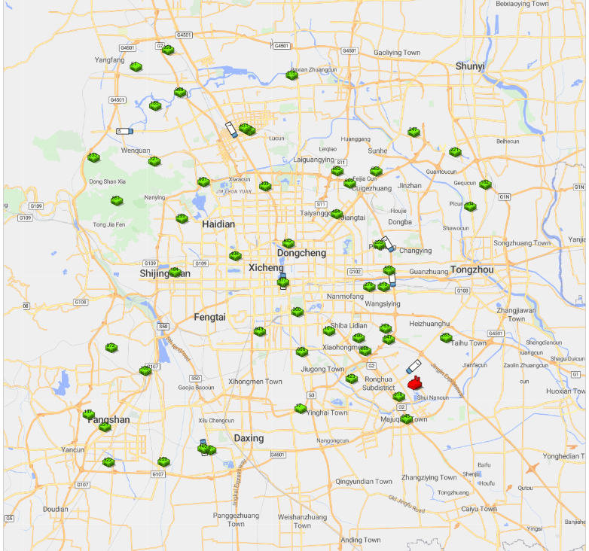

Figure 6. The running model